**Task 1: Research & Summarize**

**Sora: AI Video Generation, Comparisons, and Ethical Considerations**

**What is Sora?**  
Sora is an advanced text-to-video model developed by OpenAI that generates high-quality, realistic videos from written prompts. It can produce videos up to 60 seconds long with rich details, smooth motion, and consistent visual storytelling. Unlike previous generative models limited to still images or short loops, Sora introduces temporal consistency—meaning it handles not just what things look like, but how they move and interact over time. It can simulate environments, characters, actions, and camera movements, all guided by the input prompt. Sora uses diffusion-based techniques similar to those behind DALL·E and other image models, but it extends them to the video domain by learning patterns across both space and time.

**Comparison with DALL·E, Pika Labs, and RunwayML**  
DALL·E, also by OpenAI, focuses on generating images from text prompts. It supports detailed visuals, inpainting, and edits, but it does not create motion or sequences. Sora takes that same text-to-media concept and advances it to video, making it a more complex and capable tool.

Pika Labs and RunwayML are notable tools in the AI video generation field. Pika Labs is popular for short-form, stylized video creation and is user-friendly for creators looking to experiment. RunwayML, particularly its Gen-2 model, allows for both text-to-video and image-to-video generation and is widely used in marketing and creative projects. However, these tools often have limitations in generating realistic motion or longer coherent sequences. In comparison, Sora excels at maintaining consistent characters, physics, and scene logic across multiple frames, offering more professional-grade outputs.

**Ethical Considerations in Video Generation**  
As video generation becomes more powerful, ethical concerns grow. One of the most critical is **misuse**—such as generating deepfakes or misleading content that could spread misinformation, impersonate individuals, or manipulate public perception. To counter this, models like Sora must include safeguards such as watermarking, content filters, and usage restrictions.

Another key issue is **bias**. If training data reflects social or cultural stereotypes, the model may reproduce or amplify them in its outputs. Responsible development requires diverse datasets and ongoing auditing to minimize harm.

**Consent and copyright** are also central concerns. Using the likeness of real people or copyrighted material without permission can lead to legal and ethical problems. Finally, the impact on **creative jobs** in media, film, and advertising must be considered, as automation could displace human roles.

In summary, Sora is a breakthrough in AI video generation, outperforming current tools in realism and complexity. However, ethical deployment and regulation are essential to ensure its benefits are balanced against potential harms.

**Task 2: Prompt Engineering Practice**

Here are **5 creative prompts** across diverse domains:

**1. Education**  
*"A 15-second animated clip showing the water cycle — starting with rain falling on mountains, flowing into rivers, evaporating into clouds, and returning as rain again."*

**2. Entertainment**  
*"A 10-second cinematic scene of a futuristic city at night, with flying cars zooming between neon-lit skyscrapers and a street performer playing digital drums on a hovering platform."*

**3. Environment**  
*"A 12-second time-lapse video of a barren desert slowly transforming into a green oasis, with trees sprouting, animals arriving, and clouds forming overhead."*

**4. Technology**  
*"A 15-second clip of a robot assembling itself part-by-part in a high-tech lab, followed by it powering on and scanning the room with glowing eyes."*

**5. Social Awareness**  
*"A 10-second emotional animation showing a child planting a tree in a polluted urban area, with the environment gradually becoming greener and cleaner as the tree grows."*

**Task 3: AI + Creativity Simulation**

**Chosen Role: Educator  
Topic: *How AI Works*  
Video Length: 15 seconds  
Objective: Explain the basic concept of artificial intelligence in a fun and engaging way for students aged 10–14.**

### 🎥 SORA Video Prompt:

*"A 15-second educational animation that begins inside a child’s imagination, where a cartoon robot is learning by watching books, images, and videos. The robot starts connecting dots between pictures of cats and dogs, eventually recognizing them on its own. Background is colorful, classroom-themed with floating data and glowing circuits. The robot waves and smiles at the end with the text: 'That’s how AI learns!'"*

### Scene-by-Scene Breakdown:

**Scene 1 (0–3 sec):**

* Visual: A dreamy, cartoon-style cloud forms, representing a child’s imagination. Inside it, a friendly, round-eyed robot floats in a whimsical digital classroom filled with books, pictures, and screens.
* Motion: Pages flip, and images of cats, dogs, fruits, etc., pop up around the robot.
* Text/Narration: *"AI learns like us — by observing..."*

**Scene 2 (3–8 sec):**

* Visual: Close-up of the robot watching image slides. A glowing neural network diagram appears, showing connections between concepts (e.g., a cat image connected to the word “cat”).
* Motion: Light trails connect data points as the robot’s "brain" starts lighting up.
* Text/Narration: *"...spotting patterns in pictures and words..."*

**Scene 3 (8–13 sec):**

* Visual: The robot now confidently points at a picture of a cat and says "Cat!" and then "Dog!" to another image. A mini "thumbs-up" emoji floats beside it.
* Motion: Confetti-like data bits swirl in celebration.
* Text/Narration: *"...and finally, it figures things out!"*

**Scene 4 (13–15 sec):**

* Visual: The robot smiles, waves to the audience, and a banner floats in with the text: *“That’s how AI learns!”*
* Background: Classroom fades into a soft digital glow.
* Sound: Cheerful chime or light background music ends the video.

**Practice Activity (Without Direct SORA Access)**

## 🎬 Practice Activity: "A Short Story with a Twist"

**🎭 Role: Storyteller  
 🕒 Duration: 15 seconds  
 🎯 Objective: Create a heartwarming, visual story with an unexpected twist**

🔧 Step 1: Generate Keyframes Using DALL·E

Use the following prompts in DALL·E to create 4 keyframes that capture the story's progression. Choose a *storybook* or *fantasy cartoon* style for consistency.

✅ Keyframe 1 – The Journey Begins

Prompt:  
 *A tiny cartoon knight walking bravely through a giant, enchanted forest with glowing mushrooms, oversized trees, and fog. Whimsical storybook illustration.*

✅ Keyframe 2 – Ready to Battle

Prompt:  
 *The tiny knight stands in front of a glowing cave entrance, holding a small sword with determination. Dramatic lighting and fantasy style.*

✅ Keyframe 3 – Surprise Inside the Cave

Prompt:  
 *A friendly, oversized cartoon dragon in a pink apron, baking cookies inside a cozy, warmly lit cave kitchen. The dragon smiles and offers a cookie.*

✅ Keyframe 4 – A Cozy Ending

Prompt:  
 *The cartoon knight and dragon sit by a fireplace, happily eating cookies together. Warm, magical atmosphere in a storybook illustration style.*

✂️ Step 2: Simulate the Video in CapCut or Canva

### 📥 Import Your Keyframes

* Add each of your 4 images to CapCut or Canva in the correct story sequence.

### ⏱️ Suggested Timing

* Keyframe 1: 0–3 sec
* Keyframe 2: 3–7 sec
* Keyframe 3: 7–11 sec
* Keyframe 4: 11–15 sec

### 🎞️ Add Motion & Transitions

* Use pan or zoom-in effects for subtle motion
* Add fade-in and fade-out transitions between scenes
* Add a magical *“whoosh”* or *sparkle* sound for the twist moment

**🗣️ Step 3: Add Narration or Subtitles**

### 🎙️ Narration Script (Optional voiceover or on-screen text):

Scene 1:  
 *“Once upon a time, a tiny knight set out to fight a fearsome dragon...”*

Scene 2:  
 *“He drew his sword and entered the cave, ready for battle...”*

Scene 3:  
 *“But instead of fire...”*

Scene 4:  
 *“...he found cookies and a new friend.”*

💡 *Text Tip:* Use whimsical fonts like “Gochi Hand” or “Comic Neue” for a storybook feel.

**🎵 Step 4: Add Background Music (Optional)**

* Choose a royalty-free fantasy or light-hearted instrumental
* Fade it in at the start and out at the end
* Use YouTube Audio Library, Pixabay, or CapCut built-in tracks

✅ **Final Step: Export Your Video**

* Save as MP4 or share directly from Canva/CapCut
* Use in class, social media, or creative storytelling projects

*“”A 15-second educational animation that begins inside a child’s imagination, where a cartoon robot is learning by watching books, images, and videos. The robot starts connecting dots between pictures of cats and dogs, eventually recognizing them on its own. Background is colorful, classroom-themed with floating data and glowing circuits. The robot waves and smiles at the end with the text: 'That’s how AI learns!'"*

**

*prompt:- Cartoon-style tiny knight in shiny armor walking through a giant magical forest with glowing mushrooms, fog, and oversized trees. Storybook illustration style.*

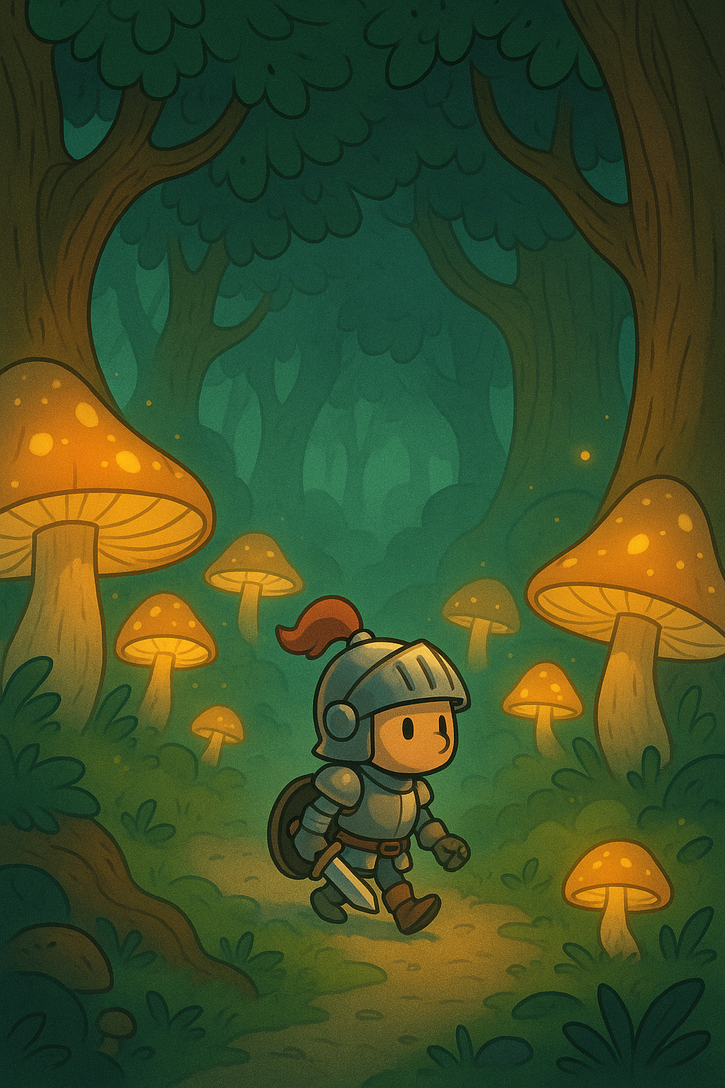

prompt:- A Short Story with a Twist

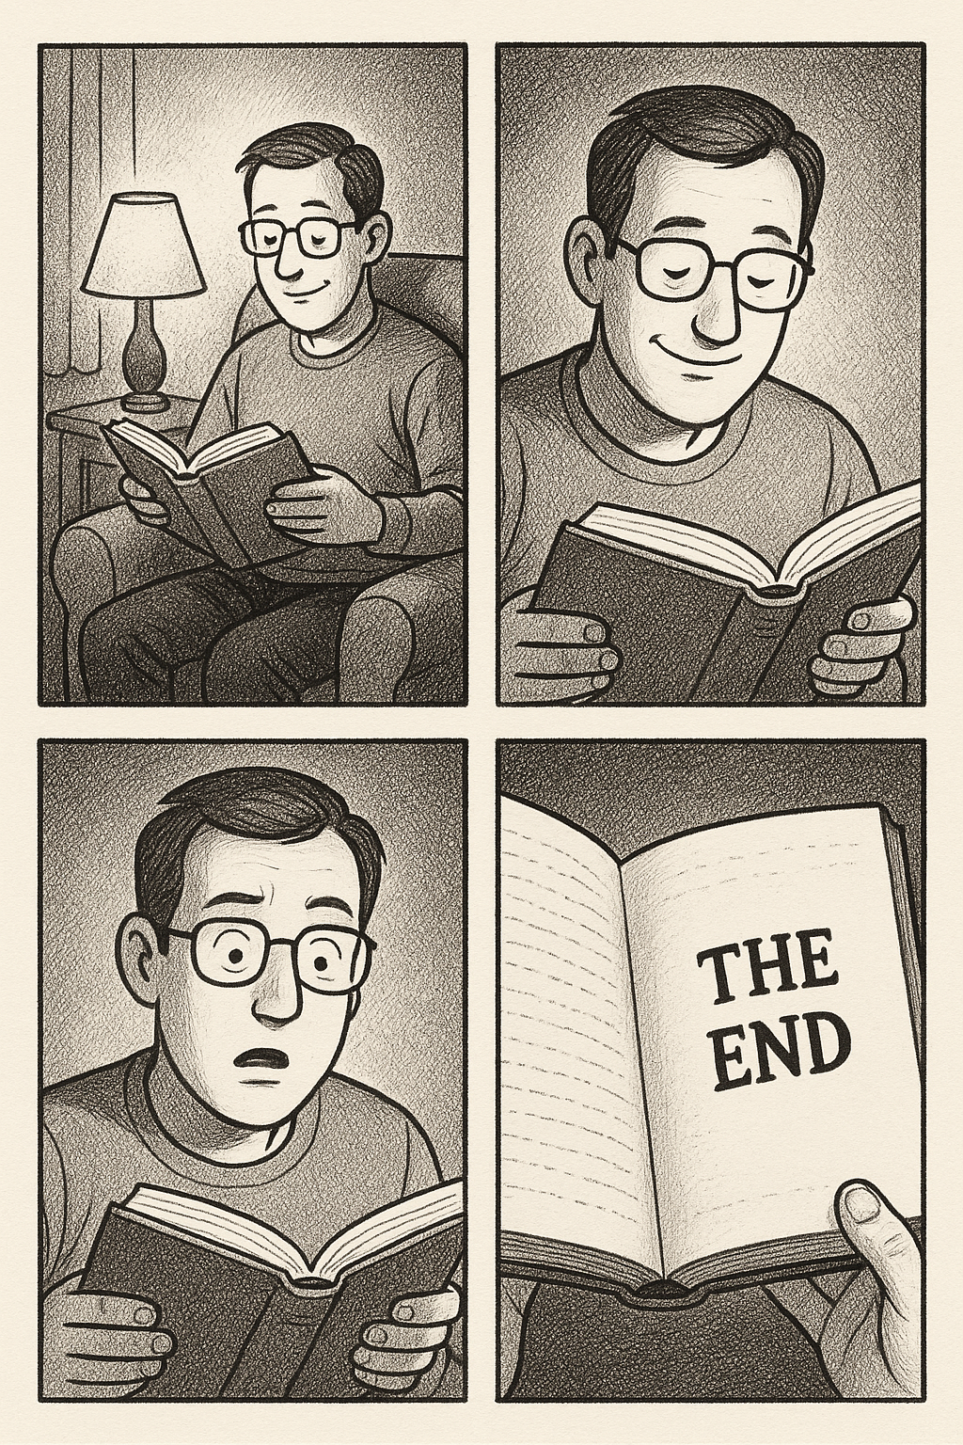

prompt:- Climate Change



prompt:- Photosynthesis

